**EXP NO:**

**DATE :**

**000WEBHOST CLOUD PLATFORM**

**AIM:**

To Create a web application and deployment in 000webhost cloud platform in Windows

Azure.

**STEPS:**

**STEP 1:** Login into Azure Account

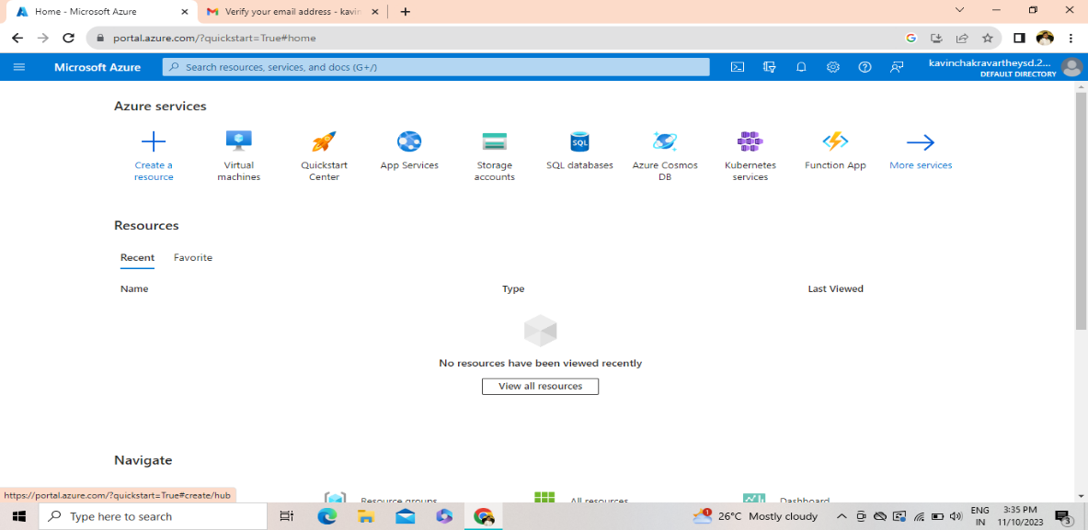

**STEP 2:** Click Virtual Machines in the Menu Bar

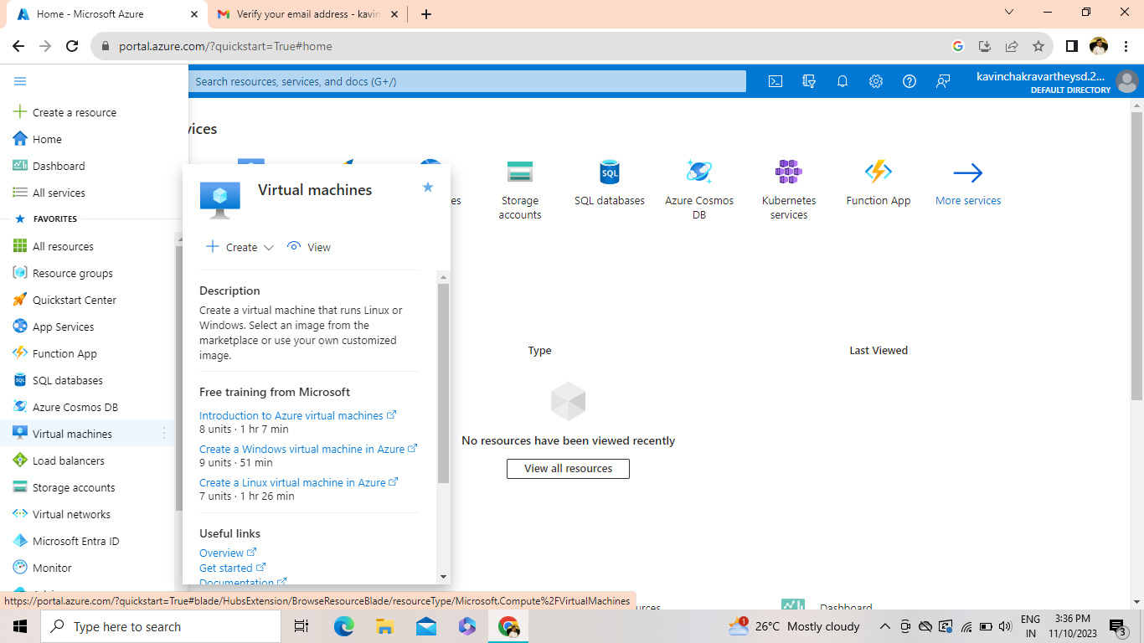

**STEP 3:** Click create

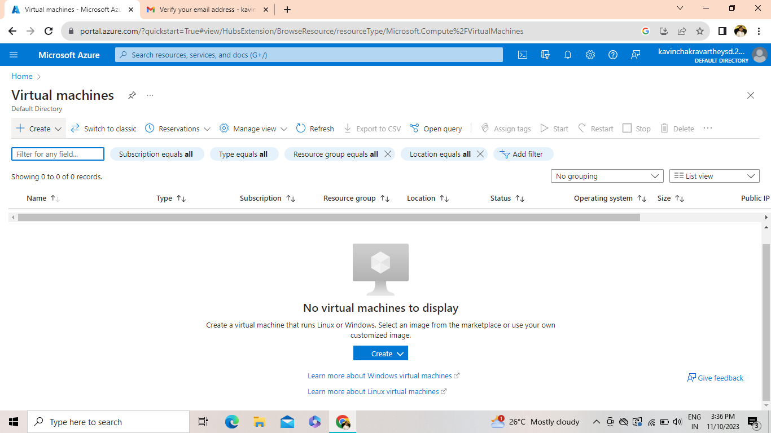

**STEP 4:** Enter all the necessary details in the input box and then click Review + Create Button.

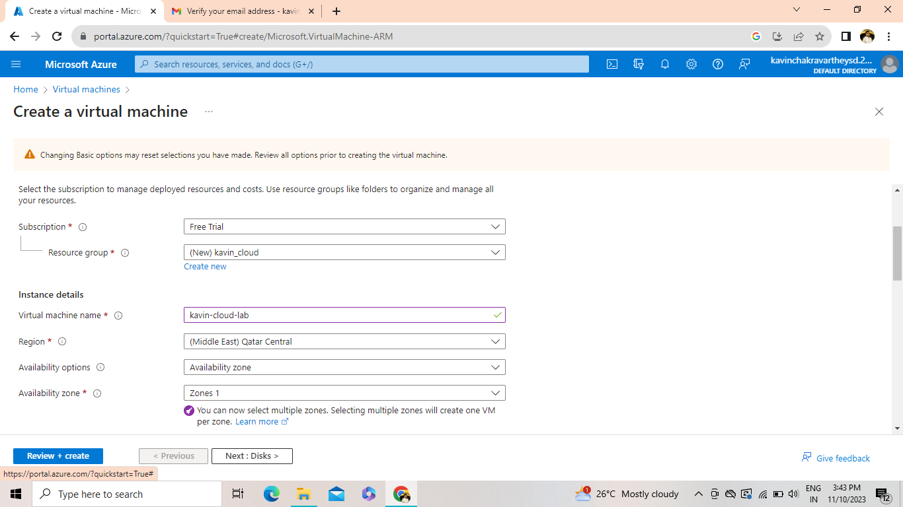

**STEP 5:** The Virtual Machine will be created and then click Go to Resource button.

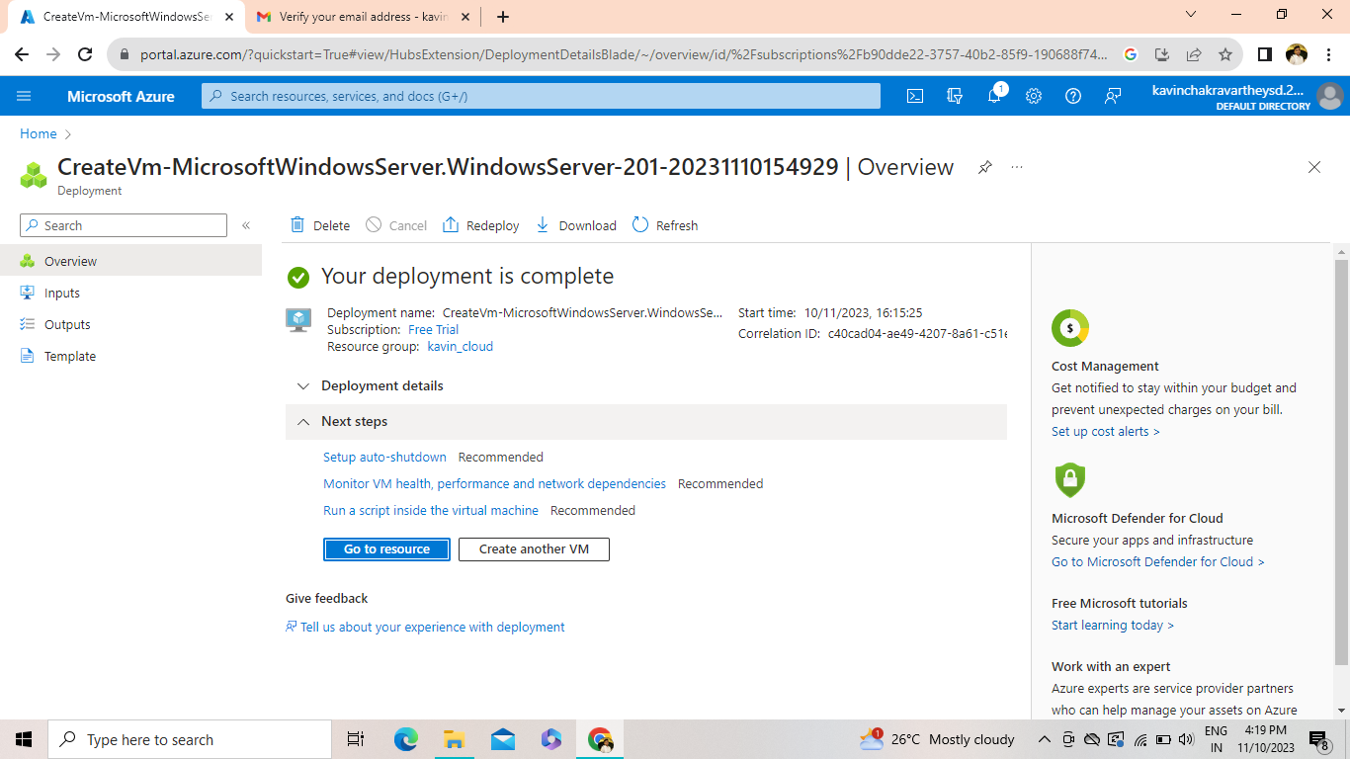

**STEP 6:** Click the connect button to connect your Virtual Machine

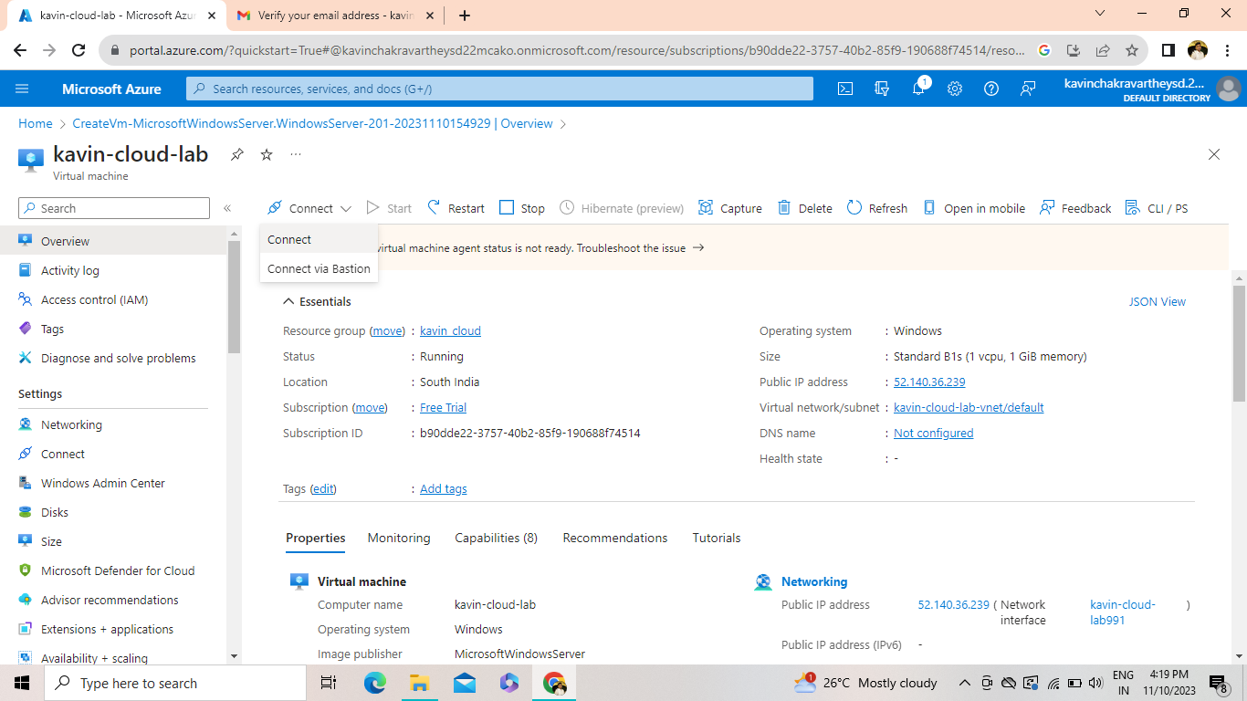

**STEP 7:** Click select button in Native RDP

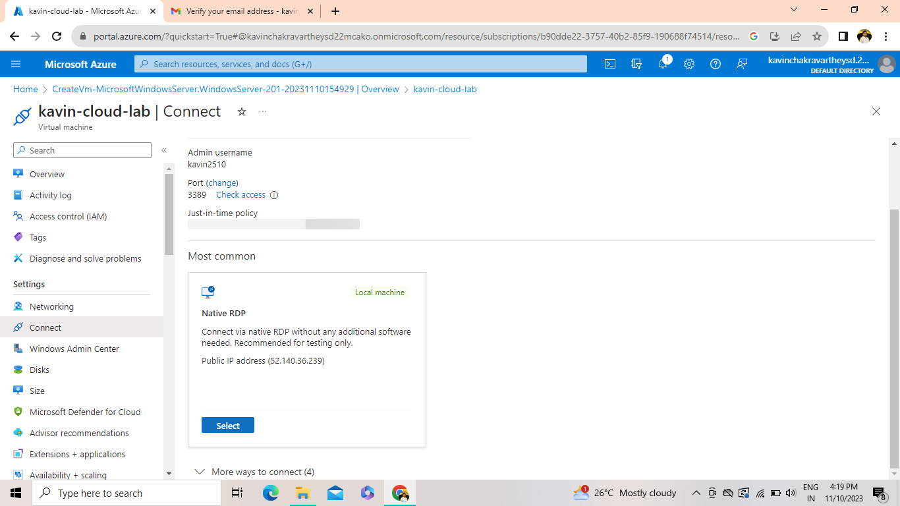

**STEP 8:** Click Download RDP file and the file will downloaded

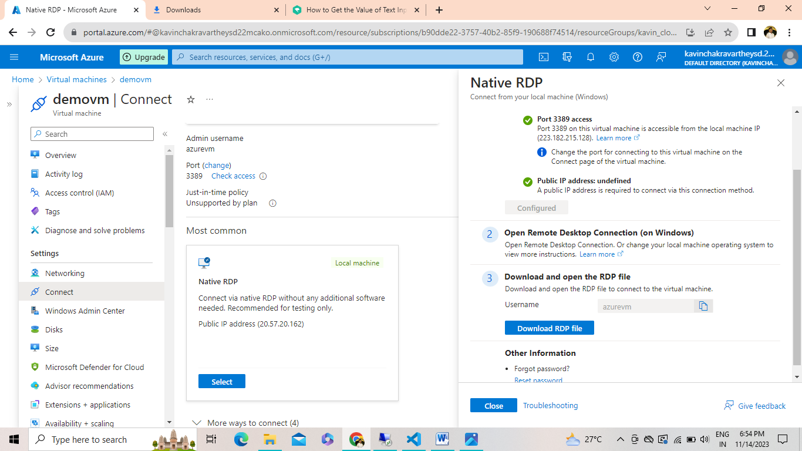

**STEP 9:** Open the downloaded file to connect to your virtual machine.

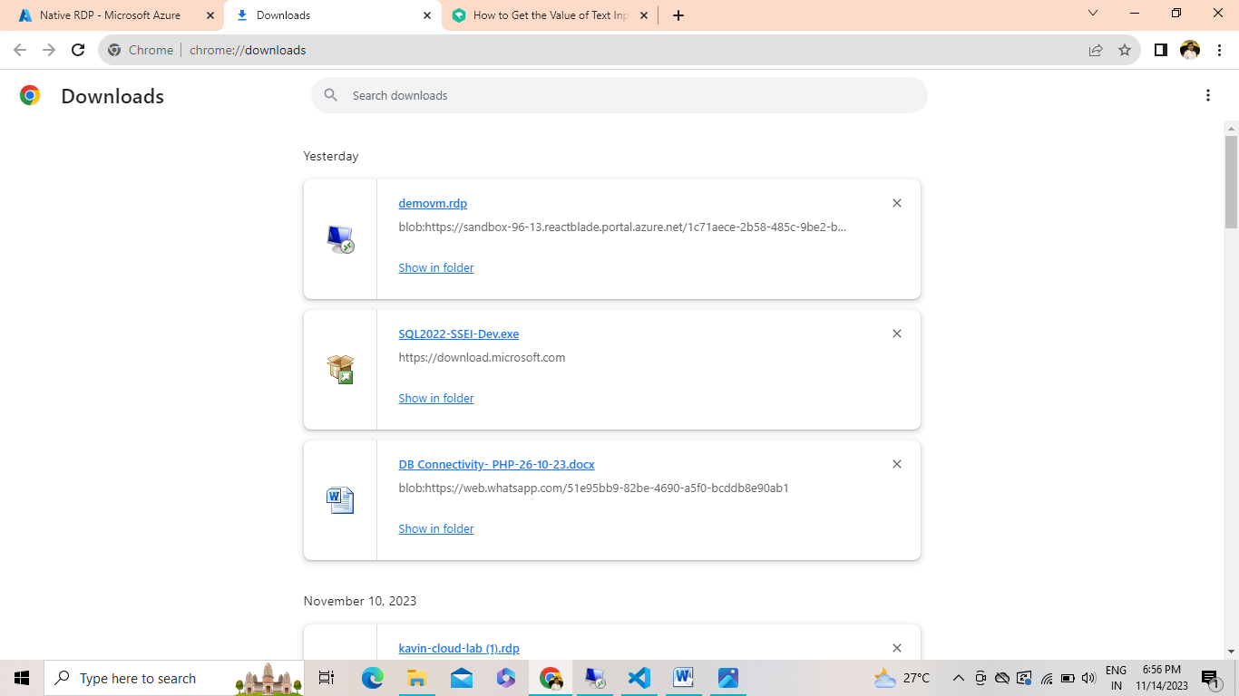

**STEP 10:** Click Connect

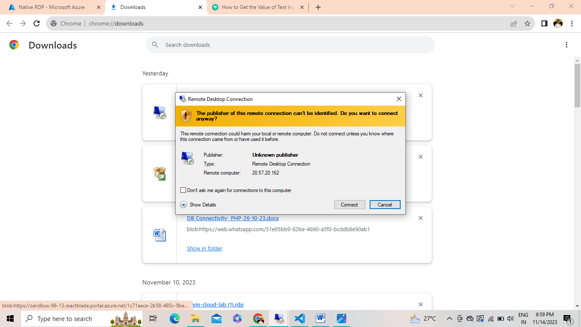

**STEP 11:** Enter your username and password and then click ok

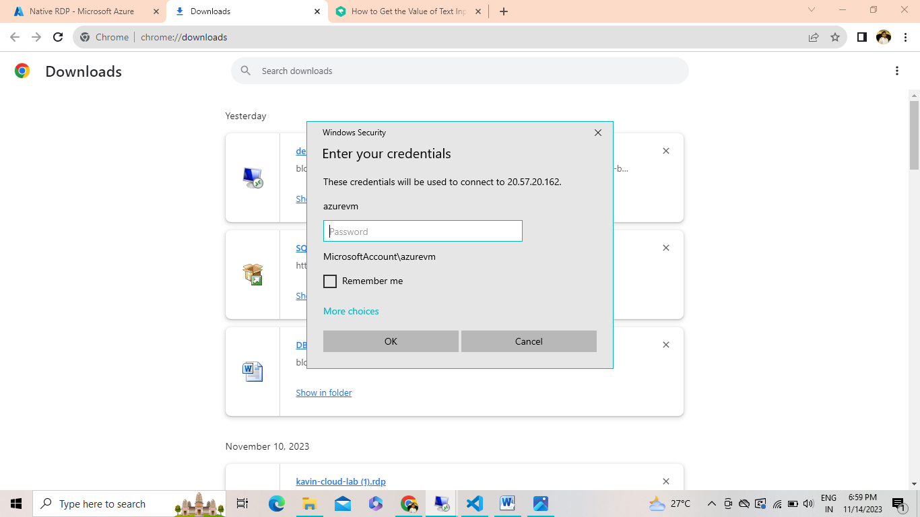

**STEP 12:** Virtual machine will be opened and then open server manger 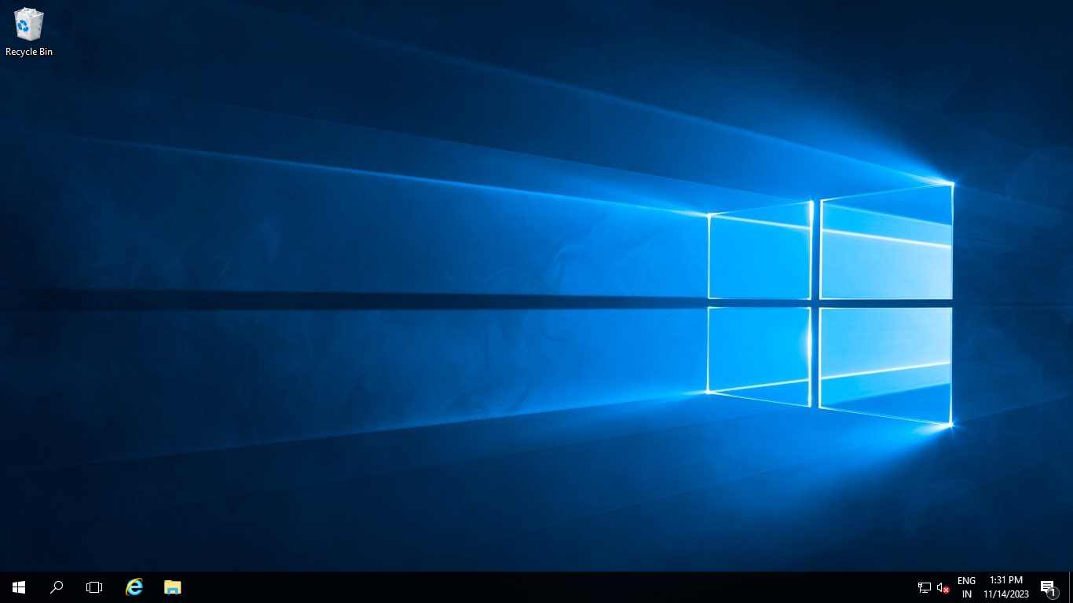

**STEP 13:** In server manager Click Tools and then select Internet Information Services Manger

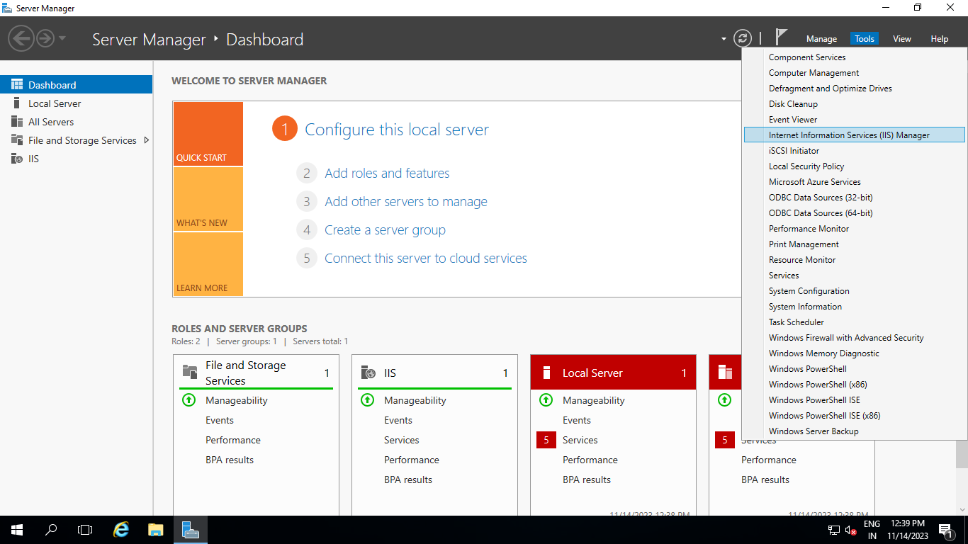

**STEP 14:** Right Click on the Sites and select Add Website

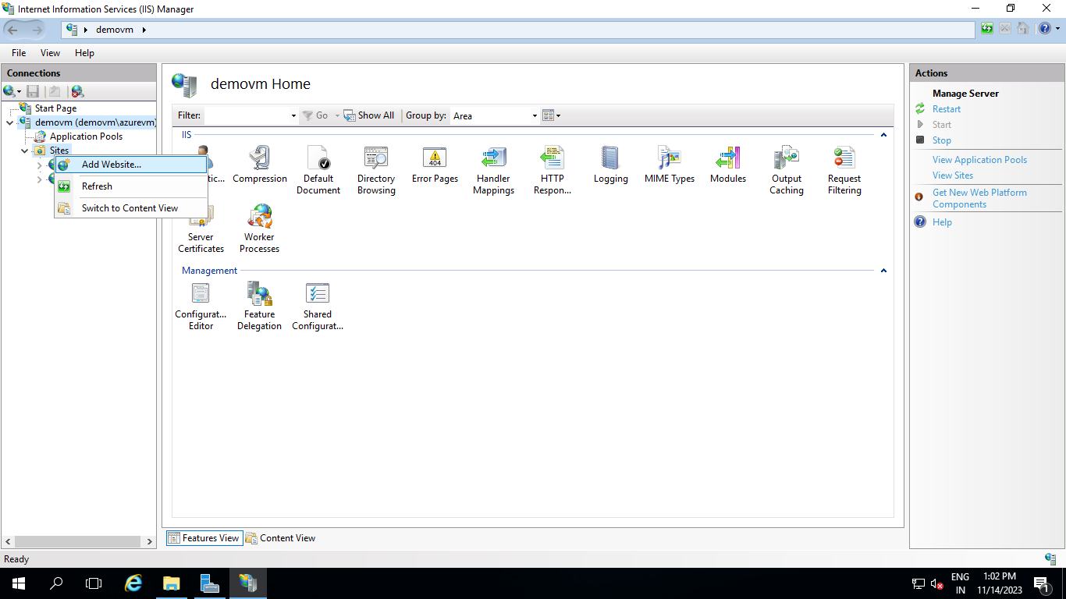

**STEP 15:** Enter the site name and choose the file path and change it to default site.

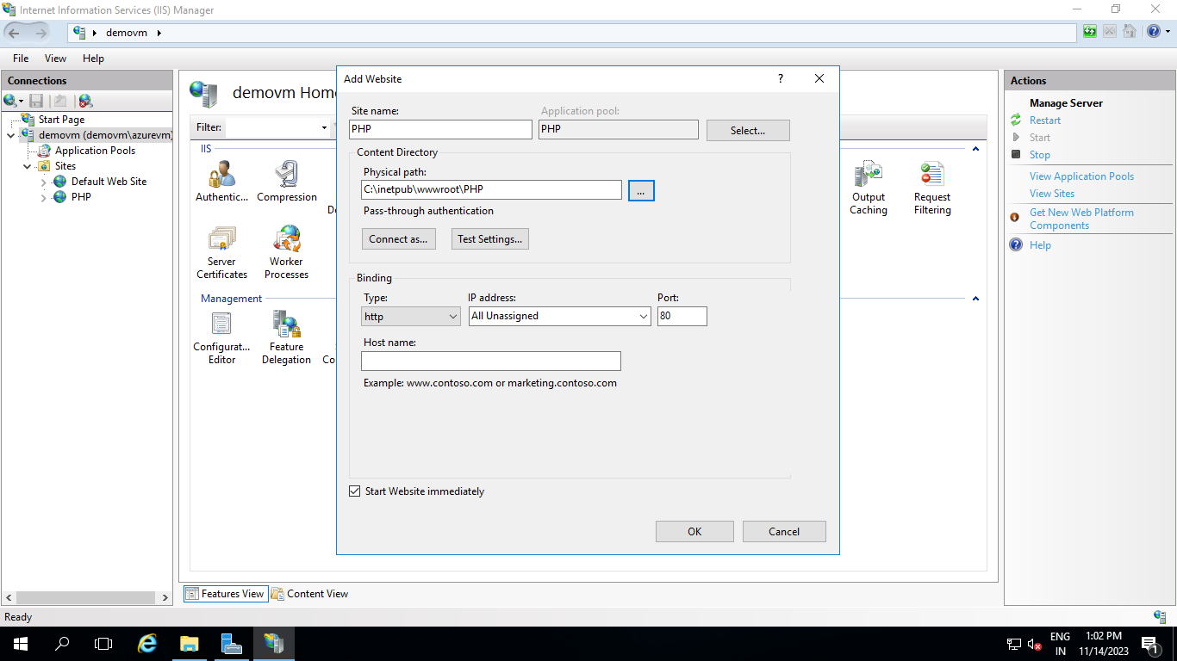

**STEP 16:** Then enter the public IP Address of the Virtual Machine in the address bar to open your site.

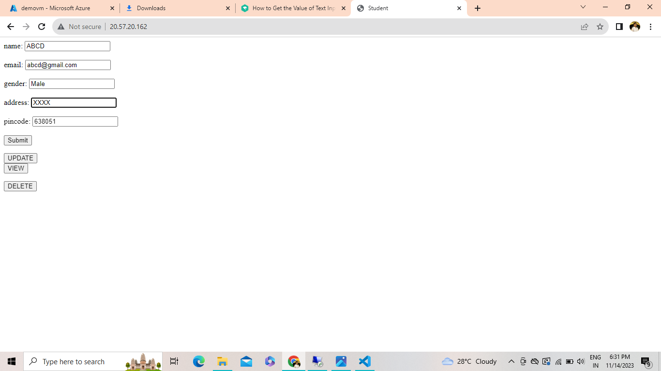

**STEP 17:** Click Submit button to submit the input details.

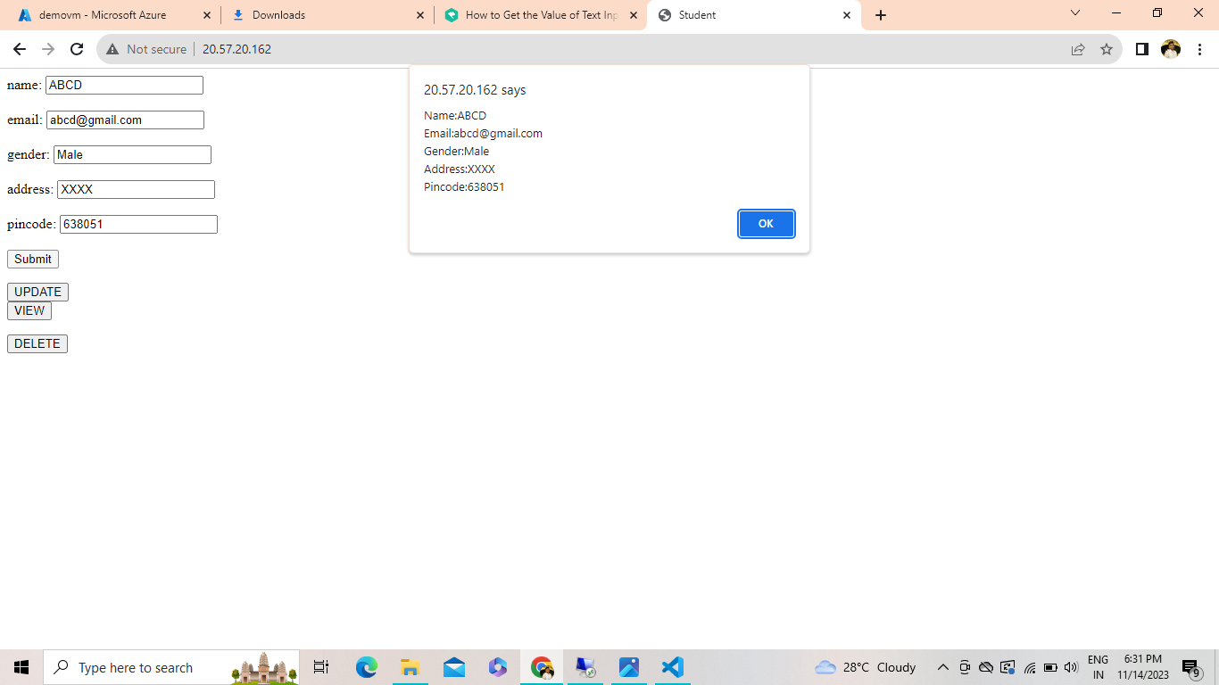

|  |  |
| --- | --- |
| CONDUCT OF EXPERIMENT(30) |  |
| RECORD(20) |  |
| VIVA(10) |  |
| TOTAL(60) |  |

**RESULT:**

Thus, the Virtual Machine in Azure has been created and executed successfully.